**Homework #3.**

**Question 1. Classification with Decision tree and Bayes**

|  |  |  |  |  |  |
| --- | --- | --- | --- | --- | --- |
|  | **Age** | **Income** | **Student** | **Credit** | **Target**  **Buys Computer** |
| 1 | Youth | High | No | Fair | No |
| 2 | Youth | High | No | Excellent | No |
| 3 | Middle | High | No | Fair | Yes |
| 4 | Senior | Medium | No | Fair | Yes |
| 5 | Senior | Low | Yes | Fair | Yes |
| 6 | Senior | Low | Yes | Excellent | No |
| 7 | Middle | Low | Yes | Excellent | Yes |
| 8 | Youth | Medium | No | Fair | No |
| 9 | Youth | Low | Yes | Fair | Yes |
| 10 | Senior | Medium | Yes | Fair | Yes |
| 11 | Youth | Medium | Yes | Excellent | Yes |
| 12 | Middle | Medium | No | Excellent | Yes |
| 13 | Middle | High | Yes | Fair | Yes |
| 14 | Senior | Medium | No | Excellent | No |

**Which class the following object is belonging to?**

Age=youth, Income=medium, Student=yes, Credit_rating=fair

**Question 2. Classification with Decision tree and Bayes.**

|  |  |  |  |  |
| --- | --- | --- | --- | --- |
| **Object** | **Body** | **Nationality** | **Marital status** | **Group** |
| O1 | Small | Germany | Single | A |
| O2 | Big | France | Single | A |
| O3 | Big | Germany | Single | A |
| O4 | Small | Italy | Single | B |
| O5 | Big | Germany | Maried | B |
| O6 | Big | Italy | Single | B |
| O7 | Big | Italy | Maried | B |
| O8 | Small | Germany | Maried | B |

* 1. Find the classification rules of the above decision table with:
* The condition attribute set {Body, Nationality, Marital status}
* Classification attribute {Group}
  1. If the following 2 objects are belong to any class? If so, which class are they belong to?

|  |  |  |  |  |
| --- | --- | --- | --- | --- |
| O9 | Big | Italy | Single | ? |
| O10 | Small | Italy | Maried | ? |

**Question 3. Given data set**

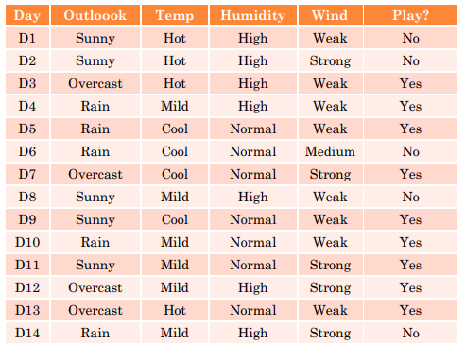

If X= (O = Sunny, Temp = Hot, Humidity = Normal, Wind = Weak),

Which answer should be? Yes or No